1. Mountain  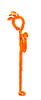  Begin by standing in Mountain pose, feet about hip width apart, hands either by your sides or in prayer position. Take several deep breaths. | 2. Hands up  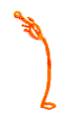  On your next inhale, in one sweeping movement, raise your arms up overhead and gently arch back as far as feels comfortable and safe. | 3. Head to knees    As you exhale, bend forward, bending the knees if necessary, and bring your hands to rest beside your feet.
4. Lunge  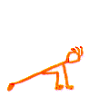  Inhale and step the right leg back | 5. Plank  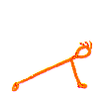  Exhale and step the left leg back into plank position. Hold the position and inhale. | 6. Stick  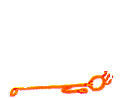  Exhale and lower yourself as if coming down from a pushup. Only your hands and feet should touch the floor.
7. Upward Dog  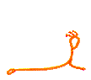  Inhale and stretch forward and up, bending at the waist. Use your arms to lift your torso, but only bend back as far as feels comfortable and safe. Lift your legs up so that only the tops of your feet and your ahnds touch the floor. It's okay to keep your arms bent at the elbow. | 8. Downward dog  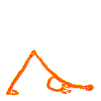  Exhale, lift from the hips and push back and up. | 9. Lunge  Inhale and step the right foot  forward.
10. Head to knees  Exhale, bring the left foot forward and step into head-to-knee position. | 11. Hands up  Inhale and rise slowly while keeping arms extended . | 12. Mountain  Exhale, and in a slow, sweeping motion, lower your arms to the sides. End by bringing your hands up into prayer position. Repeat the sequence, stepping with the left leg.

